# General Notes

* Steps for setting up a new database
  + first set up a server on the MongoDB website/MongoDB Atlas
  + to log into the server on terminal
    - copy the connection string from Atlas, paste it into the terminal, and then enter your password

# Formatting/Commands

* inserting data into a collection
  + db.{*collection name}*.insert(...)
    - insertOne, insertMany, or bulkWrite
* In order to create a database, you will first need to switch the context to a non-existing database using the use command
  + use {*database name*}
* to see the databases on the server (empty DBs won’t show up)
  + show dbs
* ex of a document

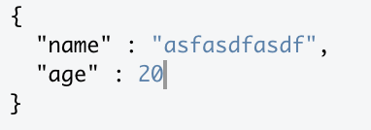

* ex of multiple documents

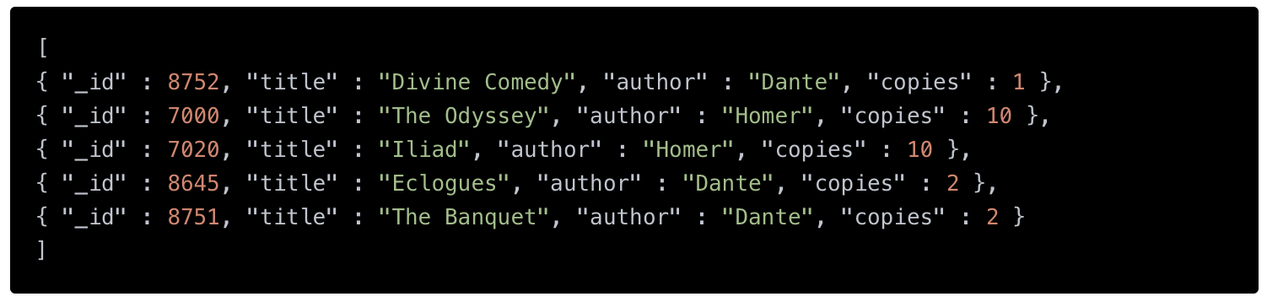

* how to drop a collection
  + db.{*collection name*}.drop()

# Main Concepts

* data is stored as JSON documents
* documents in the same collection can have different fields
* indexes improve querying speed (maybe implement in later sprints if there’s time)

# Vocab

* collection - group of documents
  + like a table in SQL

# MongoDB vs SQL

<https://www.mongodb.com/docs/manual/reference/sql-comparison/>

* row in SQL → document in MongoDB
* primary key in MongoDB is automatically the _id field
* you don’t have to explicitly create tables in MongoDB, you can just insert into a non-existant colection